FOR IMMEDIATE RELEASE

Contact: Dennine Cook/Maureen Fagan
publicrelations@gurwin.org
(631) 715-2562/ 2569

GURWIN JEWISH ASSISTED LIVING RELEASES
2019 L’DOR V’DOR CALENDAR
Award-winning calendar, starring Gurwin residents,
celebrates the vitality of the Greatest Generation

Commack, NY (January 14, 2019) – Hiding in the forest from the Nazis for months, Tina and her family relied on the goodness of others to survive. Despite her stolen childhood, she looks for the positives in life, maintaining that best advice for a good life is to be kind to others.

Such is the simple, yet sound advice from the pages of the “2019 L’dor v’dor: From Generation to Generation Calendar” produced by Gurwin Jewish ~ Fay J. Lindner Residences. Now in its seventh year, the award-winning calendar showcases 14 residents of the assisted living facility, including two Holocaust survivors, two couples married more than 60 years, and eight other seniors whose pearls of wisdom are forever immortalized in its pages.

Each model was selected for participation in the calendar project based on his or her unique personal story and life experiences. Models sat for professional hair and makeup, and portraits were taken by a local photographer. The day-long shoot included a feature interview of each model about their lives and advice, as well as a behind-the-scenes look at the making of the calendar which was filmed by a professional videographer and is now available for viewing on Gurwin’s website at bit.ly/Gurwin2019Calendar

- next -

- 2 -
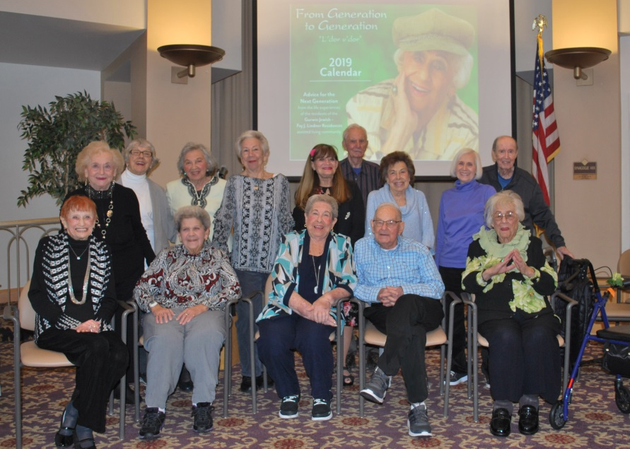
“We are fortunate to have among us members of the Greatest Generation,” said Stuart B. Almer, President and Chief Executive Officer of the Gurwin Family of Healthcare Services. “Our unique annual calendar preserves the events and memories of a bygone era, while offering valuable advice to future generations. It is a tribute to the everyday heroes who
lived during extraordinary times.”
14 residents at Gurwin Jewish ~ Fay J. Lindner Residences assisted living
facility star in the 2019 L’dor v’dor From Generation to Generation Calendar.

“The annual ‘Calendar Reveal’ is a much anticipated event for the residents and their family, as well as our staff,” said Staci Rosenberg-Simons, Director of Community Relations at Gurwin’s assisted living facility. “From the red carpet arrival, to the paparazzi photos and interviews, to the autographing of the calendar pages, the event brings a certain air of celebrity magic to our facility. We are pleased to continue this tradition each year and are proud to honor our inspirational residents and share their sage advice.”

A copy of the calendar is available free of charge by visiting bit.ly/Gurwin2019Calendar.

ABOUT THE GURWIN FAMILY OF HEALTHCARE SERVICES
Voted “Best of Long Island” in assisted living, Gurwin Jewish~Fay J. Lindner Residences is a 201-bed community in Commack, NY. It is part of the Gurwin Family of Healthcare Services which includes the Gurwin Jewish Nursing & Rehabilitation Center, a 5-star, 460-bed nursing care facility offering skilled nursing care, short-term rehabilitation, respiratory and ventilator dependent care, on-site dialysis, memory care, and palliative and hospice care. The nursing center also includes both medical and social Adult Day Care Programs, two home care programs, and a proposed independent living community, Fountaingate Gardens. Follow Gurwin on Facebook (bit.ly/GurwinAssistedLiving) and Twitter (@GurwinJewish).

