______________________________________________________________________________________________________________________________________________
10AM-Knitting/Latch Hook 3  11AM-Word Search  1:30PM-Group Exercise  2:30PM-Sensory Stimulation  December 2nd to 10th 2018  Happy Hanukkah | 10AM-Walking Group 4  11AM-Holiday Sand Art  1:30PM-Bowling  2:30PM-Holiday Table Talk  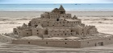 | 10AM-Beading 5  11AM-Holiday Sing Along  1:30PM-Men Wood Work  2:30PM-Table Tennis | 10AM-Reminice/Holiday’s 6  11AM-Group Exercise  1:30PM-Holiday Art & Craft 2:30PM-Miniature Golf | 10AM-Memory Game 7  11AM- Fill in the Blanks…  1:30PM-Name That Tune  2:30PM-Woman Spa Day
10AM-Holiday TRIP 10 11AM-Cinema of the Art Trip  1:30PM-Puzzle’s  2:30PM-Group Exercise | 10AM-Holiday Craft 11  11AM-Stretch & Strengthen  1:30PM-Holiday Word Search 2:30PM- Air Hockey  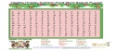 | 10AM-Puzzle’s 12  11AM-Walking Group  1:30PM-Holiday Baking  2:30PM-Name that Holiday tune | 10AM-Sensory Stimulation 13  11AM-Bingo 1:30PM-Word Search 2:30PM- Senior Zumba | 10AM-Holiday Spelling Bee 14  11AM-Knitting  1:30PM-Men Spa Day  2:30PM-Table Talk
10AM-Trivia 17  11AM-Table Tennis  1:30PM-Fill in the Blank  2:30PM-Group Exercise | 10AM-Air Hockey 18  11AM-Fitness Bingo  1:30PM-Senior Jazzercise  2:30PM-Basic Computer | 10AM-Puzzle’s 19  11AM-Basketball  1:30PM-Holiday Art & Craft  2:30PM-Crochect/Knitting | 10AM-Holiday Sing Along 20  11AM-Body Bingo  1:30PM-Senior Jazzercise  2:30PM-Bowling  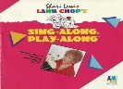 | 10AM-Memory Game 21  11AM-Family Feud  1:30PM-Nail Manicure  2:30PM-Walking Group  1st Day OF Winter
9AM-Memory Game 24  10AM-Family Feud  1:30PM-Senior Zumba  2:30PM-Karoake  Early Dismissal  2:30pm | 25  December 25th 2018  Christmas Day CLOSED | 10AM-Basic Computer 26  11AM-Memory Game  1:30PM-Stretch & Strengthen  2:30PM-Sensory Stimulation | 10AM-Name that Tune.. 27  11AM-Bowling  1:30PM-Table Talk About…  2:30PM-Finger Painting | 10AM-Computer Class 28  11AM-Yoga/ Michelle  1:30PM-Spa Day  2:30PM-Holiday Talk About..
9AM-Bingo 31  10am-Group Exercise  12:00PM-Rocking Eve Party/Kenny Hendricks  1:00 PM-Refreshment  Early Dismissal 2:30 | 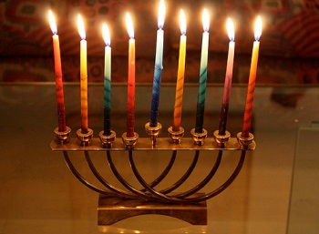 | All Activities are Subject to  Change.  Activities Question Contact:  Pauline Hazzard | Meal Time  Breakfast: 9:30am  Lunch: 12 Noon  Free Time: 1:00pm  Snack: 3:30pm | Social Adult Day Program  New year Day 2019  1/01/2019  Closed
MONDAY TUESDAY WEDNESDAY THURSDAY FRIDAY

