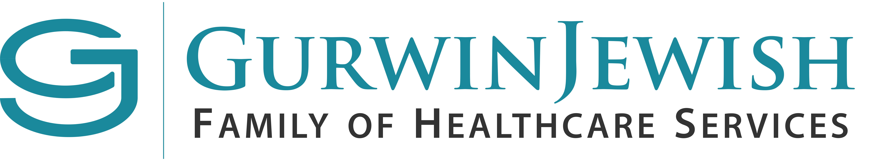

FOR IMMEDIATE RELEASE September 27, 2018
Contact: Dennine Cook/Maureen Fagan
publicrelations@gurwin.org
631. 715.2562/69
GURWIN EARNS TOP HONORS
IN FORTUNE MAGAZINE’S
BEST PLACE TO WORK IN AGING SERVICES LIST

National Honor Comes on the Heels of Inclusion
on Best Workplaces in NY List

Commack, NY – Fortune Magazine today revealed its first-ever list of Best Places to Work in Aging Services, bestowing top honors on the Gurwin Family of Healthcare Services in Commack, NY. Gurwin was ranked #1 out of 50 organizations throughout the country that provide services to the frail and elderly. It is the second prestigious accolade the organization has won in recent months from Fortune Magazine. Earlier this summer, Gurwin was named one of the top 25 Best Places to Work in New York among small- and medium-size workplaces.

The esteemed honors stem from polling data gathered by the Great Place to Work Institute, an independent research and consulting firm. Employees from across the Gurwin healthcare continuum participated in the Institute’s staff satisfaction survey, including the Gurwin Jewish Nursing & Rehabilitation Center, Gurwin Jewish Fay J. Lindner Residences assisted living community, Gurwin Certified Home Health Agency and Gurwin Adult Day Care Programs.

According to the survey data, 98 percent of Gurwin employees who participated reported they were proud to work at Gurwin, noting that the organization provides a “great atmosphere” in which to
work and “great bosses.” Gurwin was also lauded for “great challenges and communication.”

- next -

- 2 -

“We are delighted to be recognized with this endorsement of the Gurwin organization by a national and highly regarded publication such as Fortune Magazine,” said Stuart B. Almer, President and Chief Executive Officer. “We fully appreciate the challenges inherent in the work our employees do on a daily basis for those who turn to Gurwin for care, which is why we work diligently to create an enriching environment that supports and rewards our employees. From a generous benefit package and competitive salaries, to smaller, more personal gestures such as employee appreciation barbeques, complimentary chair massages, team-building exercises and spirit day celebrations, our goal is to attract and retain the best talent to provide the highest quality of care for the more than 1000 people we serve each day.”

ABOUT THE GURWIN FAMILY OF HEALTHCARE SERVICES
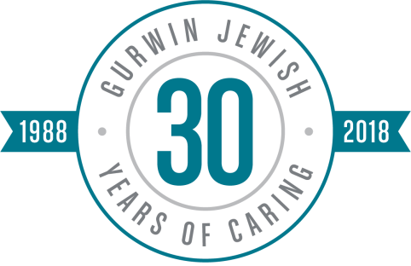
The Gurwin Family of Healthcare Services is a renowned healthcare provider which offers a full continuum of healthcare services for the frail and elderly on a 34-acre campus in Commack, NY. The campus is home to the 5-star rated nursing and rehabilitation center which provides skilled nursing care, rehabilitation therapy, advanced care, ventilator and respiratory care, on-site dialysis and infusion therapy, memory care, and palliative and hospice care, as well as both medical and social Adult Day Programs, and home care programs. The campus is also home to Gurwin Jewish Fay J. Lindner Residences assisted living community, and a proposed independent living community, Fountaingate Gardens. Follow Gurwin on Facebook (bit.ly/GurwinNursingRehab) and Twitter (@GurwinJewish).

# # #

